Faculty Supplemental Payment Requests

FPA Faculty may receive a contractual or one time supplement to their salary based on agreements with the institution. Review this folder to see how the online forms allow for the submitting of information to inform FPA accounting of the expected supplement.

Faculty Supplemental Payment Request:

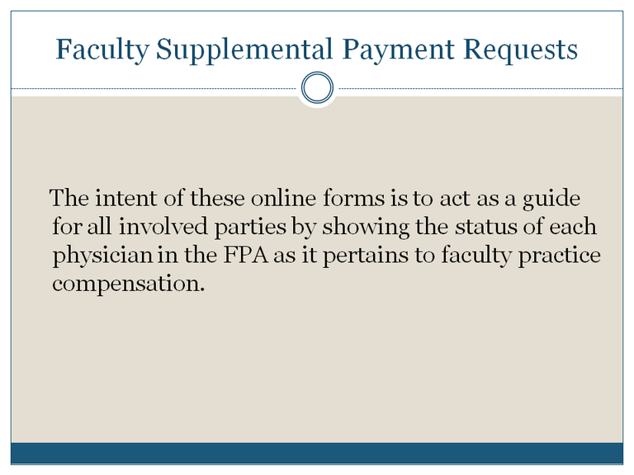

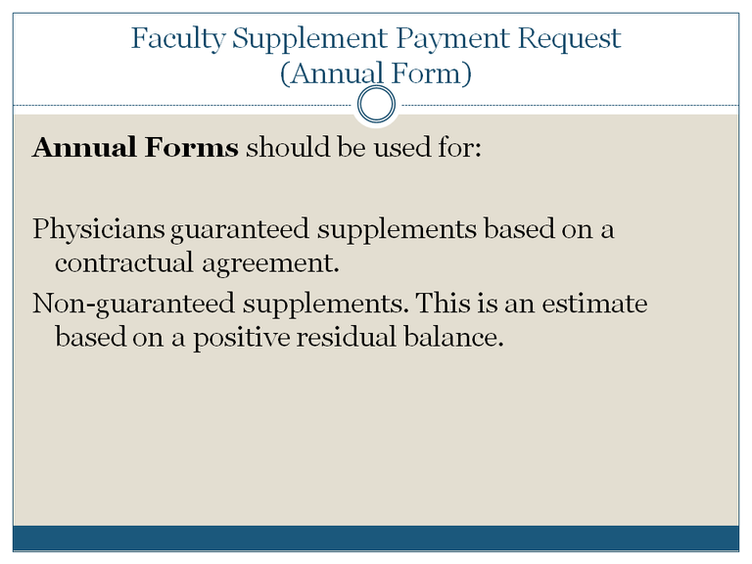

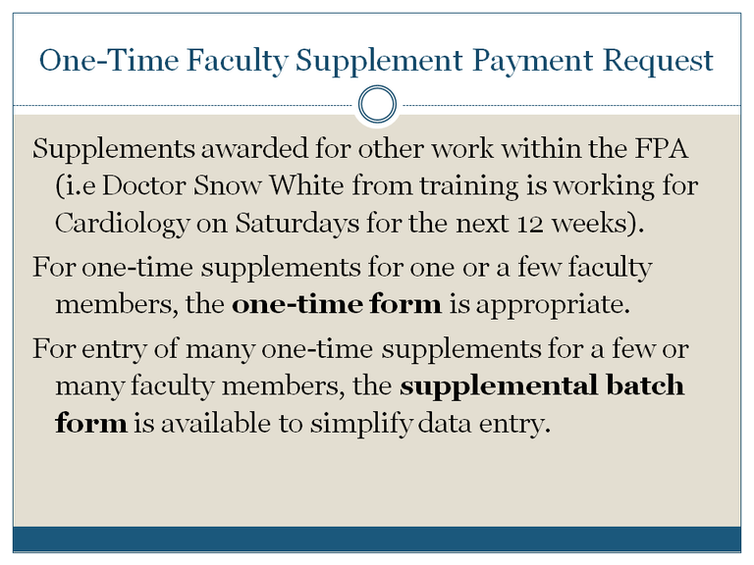

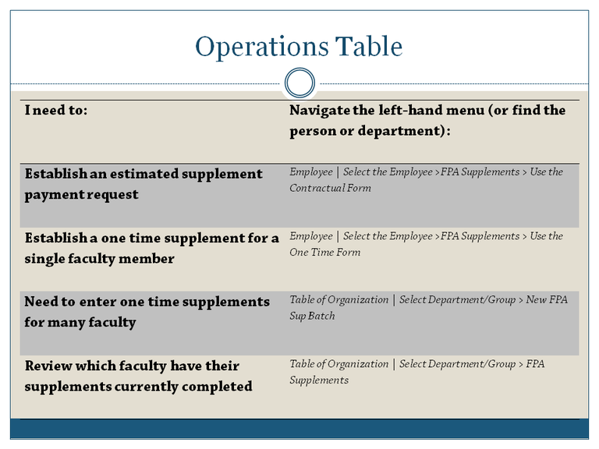

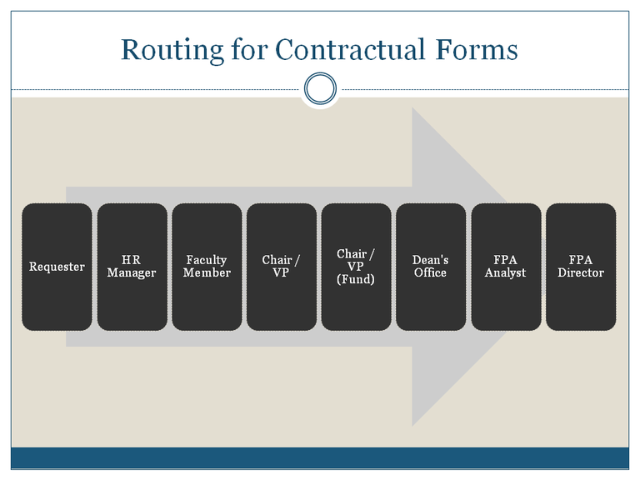

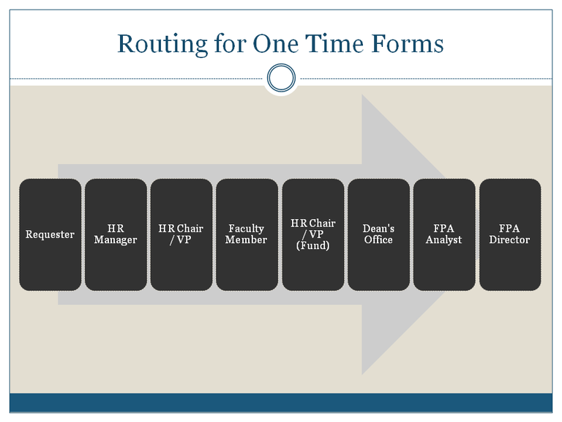

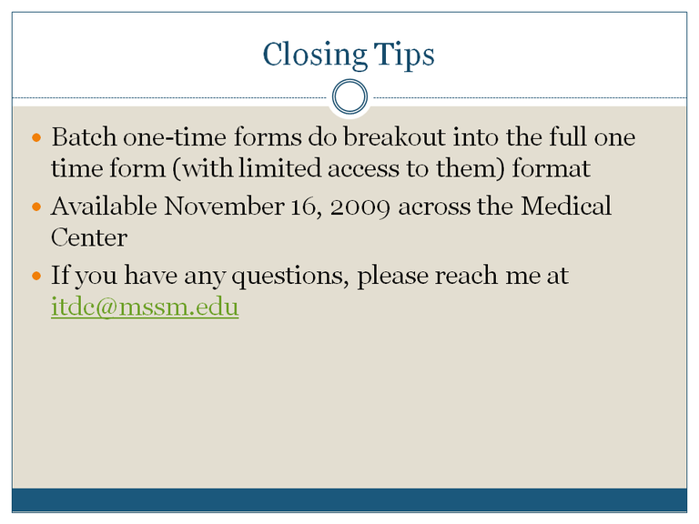

Understanding the Online Faculty Supplemental Payment Requests Process
by Daniel Klinger — last modified Sep 14, 2010 12:11 PM
Start here for a further understanding of what you are being asked to do with these forms.

What are these payment requests?
The intent of these online payment requests are to act as guides for all involved parties and to show the status of each physician in the FPA as it pertains to faculty practice compensation.

What forms should I be using?

Faculty Supplement Payment Request (Annual Form):
- Physicians guaranteed supplements based on a contractual agreement.
- Non-guaranteed supplements. This is an estimate based on a positive Residual Balance.

One- Time Faculty Supplement Payment Request:
Some physicians are given a supplement for other work within the FPA (e.g., Dr. Snow White from Anesthesiology is working for Cardiology on Saturdays for the next 12 weeks). In these cases, the one-time payment request is appropriate. When there are many one-time payment requests that need to be entered for a department, the HR Manager can use the supplemental batch form to simplify the data entry.

How does this fit into my work flow?
The work flow for the Faculty Supplemental Payment Requests are listed below. Steps 1 - 3 are necessary, but do not need to occur in the order listed; you can begin the form and save it as a draft.
- Gather the fund numbers and object codes that will be used. Make sure all parties are aware of the transaction.
- For auditing purposes, some of the supplemental forms will require documentation to be attached to the transaction. Gather supporting details (Example: supplemental contracts).
- Instead of filling out a paper faculty supplement payment request, you will fill out and submit a form online.
- Like many Sinai Central transactions, the payment request will go through at least 3 stages of approval (fund owner, departmental, and finance).
- If there is a discrepancy between the supplemental types, or required documentation, the Dean's Office or FPA accounting group will intervene when appropriate.
- Once the payment request has completed its business, the requester receives an email stating that supplemental form has been processed.

What do I need to start entering the Faculty Supplemental Payment Requests?
To work on the payment requests, you will need:
- To activate your Sinai Central user account. You may already be using Sinai Central for purchase orders, human resource transactions, or general ledgers. If you've never used Sinai Central, see Activating Your Sinai Central Account.
- Access to HRTS.
- The fund(s), object code(s), and required documentation that are being used to fund the supplements.
- Some of your time.

Quick Start Table
by Daniel Klinger — last modified Dec 10, 2009 11:49 AM
Use this quick start table to guide you on where the tool you need is in Sinai Central.
I need to: | Navigate the left-hand menu (Find the Employee or Department)
Establish an estimated supplement payment request | HR > HR Transactions > Select | Employee (Select the employee)  > FPA Supplements > Contractual Form
Establish a guaranteed supplement payment request | HR > HR Transactions > Select | Employee (Select the employee)  > FPA Supplements > Contractual Form
Establish a one-time supplement payment request for  a single (or a few) faculty members | HR > HR Transactions > Select | Employee (Select the employee)  > FPA Supplements > One Time Form
Establish a one-time supplement payment request for many faculty members | HR > HR Transactions > Table of Organization  (Select Department/Group) > Create FPA Sup Batch
Review which faculty have their supplements currently  completed | HR > HR Transactions > Table of Organization  (Select Department/Group) > FPA Supplements

Document Actions

Working with the Faculty Supplement Payment Requests (Annual Form)
by Daniel Klinger — last modified Dec 05, 2009 07:52 PM
Up one level
This is a step-by-step walk through of how to work with the form.

Overview
- Log into Sinai Central, Navigate and Select the Employee
- Select the Form
- Working with the contractual form
- General Information
- Payment Information
- Attach Documentation and Submit the Form

Log into Sinai Central, Navigate and Select the Employee
- Log into Sinai Central.
If you've never used Sinai Central before, see the instructions for obtaining a username and password at Activating Your Sinai Central User Account.
Access to HRTS is activated by an HR Manager in your department after attending a training session.
- From the Sinai Central left-hand menu (that shows all Sinai Central service areas), select HR > HR Transactions.
You may need to click on Home in the top right hand corner of the screen to expose all Sinai Central service areas available to you.
The HR Transactions menu displays in the left-hand menu.
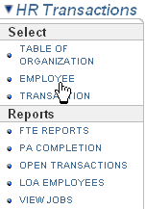
- From the Select sub-menu, click on the EMPLOYEE option.
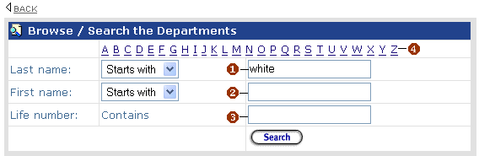
Enter the person's last name (1), first name (2) or life number (3) into the fields provided. You can also browse the employees within the department by selecting a letter (4).
- Click on the Search button.
- Click on the name to select the employee. The left hand menu will expand and the main section of your screen will show you the Employee's Profile. Employee Profiles contain*:
  - a list of department personnel that can create performance appraisals and personnel actions for the employee
  - appointment, contact, and emergency contact information
  - salary funding and payroll information
*Depending on the roles established for you in HRTS, you may not see all of the sections listed.
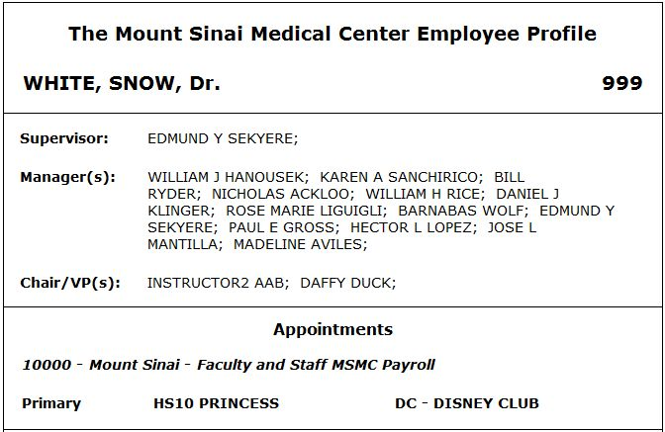
- From the user sub-menu (under the employee's name), select FPA SUPPLEMENTS.
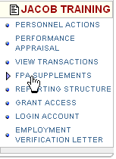

Select the Form
- Supplemental Requests that have been electronically submitted are available in a table below for a quick review and access of their status.
A departmental view of what supplemental payment requests have been completed for faculty is an option available from the Table of Organization for HR Managers.
- Depending on the type of Supplemental Payment Request that you are submitting you will need to click on the Add Contractual Form or Add One Time Form button. Use this table to assist you with choosing which form to use. In this case click on the Add Contractual Form button to proceed.
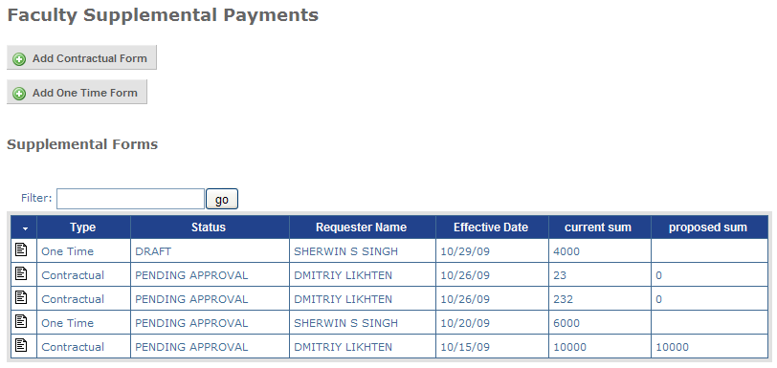

Working with the contractual form
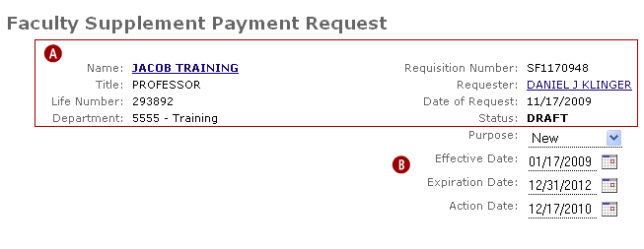
- Review the top header information for accuracy.
Note the requisition number will be one of the faster ways of referencing a payment request with other business units and Sinai Central user support. You do not need to write these down, you can always find them later with the search tools available.
- In the next section:
  - Select a Purpose for the payment request (is it a New, Renewal, Change, or Termination?) from the drop-down menu.
  - Enter the period for the payment request by entering the Effective Date and Expiration Date. You can use the calendar tool to select a properly formatted date (or enter a date with the MM/DD/YYYY format).
Currently, the Effective date can be back dated.
  - Enter an Action Date. This date is a "reminder" for the requester that is entering the information on the form . Sinai Central will send an email notification to the requester to come back to the system and take further action based on this date.

General Information
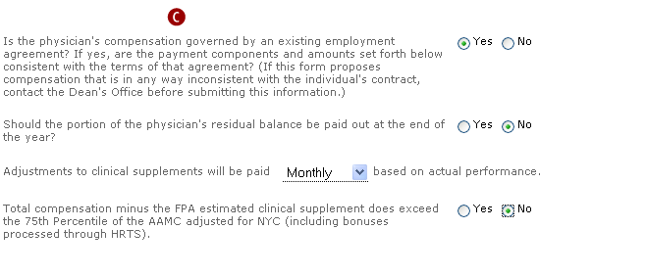
- All questions must be answered in this section of the form to be valid.

Payment Information
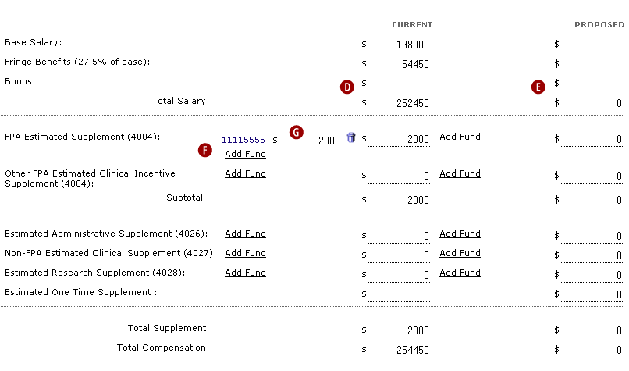
- Values that can be entered in the CURRENT column should reflect a contractual agreement already in place .
The bonus line that is available should be filled out with the amount stated in the contract.
- Values entered into the PROPOSED column should reflect an estimate for the time frame period specified above.
Currently the human resources personnel record (and transactions in HRTS) are not tied to this module. Entering a bonus or changes to the base salary here will not constitute a salary increase for a person.
- For each supplement chosen, you are able to add and delete funding sources and the allocation per fund.

Adding, Deleting and Changing Sources
Adding Sources: Clicking on the Add Fund link will expose the fund picker.
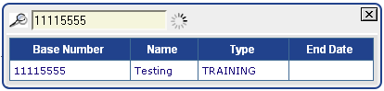
Type a fund name or number into the field available. The fund picker will begin to generate a list of funds that are available at the Medical Center as you are typing. Once you find the source, click on the fund code and it will be added as a source.
Splitting sources: To split the funding on a supplement click on the Add Fund link that appears directly under the present supplement source.
Deleting sources: Click on the garbage can icon to delete a line of salary source information.
Changing sources: To change a supplement source, you will need to delete the original source and then add a new one.
- For each fund entered, enter an amount reflecting the allocation towards the payment. The total payment will be available for you (and calculated automatically when you use split funding) in the appropriate column (CURRENT or PROPOSED).

Attach Documentation and Submit the Form
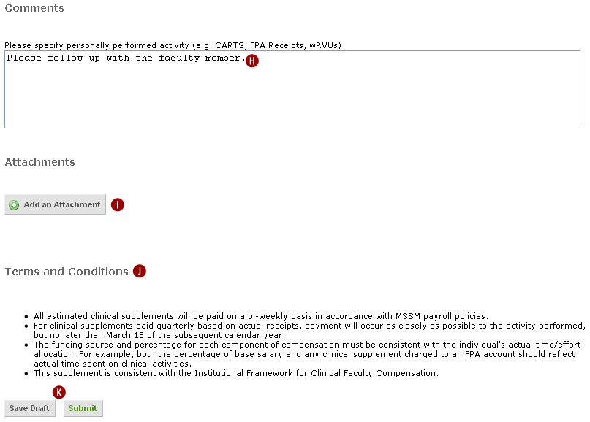

- In the comments section, you can enter a comment surrounding the transaction. As noted on the form, this is place you would want to specify faculty personally performed activities (e.g. CARTS, FPA Receipts, wRVUs).
- Click the Add an Attachment button to do so.
- Review the Terms and Conditions stated.
- Click on Save Draft to save the work done on the form so that you can come back later and work further on it. Click on Submit to send the form forward for approvals. If you click on Submit and the form does not change its status up top, you may have missed a critical portion of information. Look for red text pointing out what is missing from the form and correct it appropriately.
The roles associated with the approval chain are based on roles in HRTS.

Working with the One Time Supplemental Payment Requests (Batch)
by Daniel Klinger — last modified Dec 04, 2009 05:11 PM
Up one level
Not only can you enter these supplemental payment requests one form at a time, but you can speed up your data entry by taking advantage of a batch entry form. Here is a step-by-step walk through of how to work with the form.

Overview
- Login and Navigate to the Table of Organization
- Filling Out the Form
- Individual Faculty Entry

Login and Navigate to the Table of Organization
- Log into Sinai Central.
If you've never used Sinai Central before, see the instructions for obtaining a username and password at Activating Your Sinai Central User Account.
Access to HRTS is activated by an HR Manager in your department after attending a training session.
- From the left hand menu, select HR > HR Transactions > Select | TABLE OF ORGANIZATION.
- Select the department (where the faculty are located) from the Select Department drop-down menu.
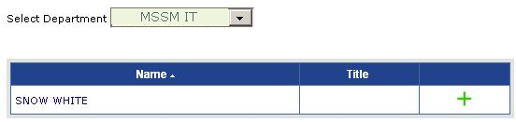
The left hand menu will expand.
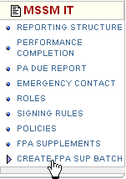
- Select CREATE FPA SUP BATCH from the left-hand menu.

Filling Out the Form
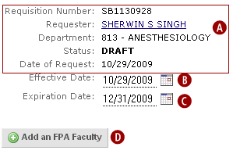
- Review the top header information for accuracy.
Note the requisition number will be one of the faster ways of referencing a payment request with other business units and Sinai Central user support. You do not need to write these down, you can always find them later with the search tools available.
- Enter an Effective Date. You can use the calendar tool to select a properly formatted date (or enter a date with the MM/DD/YYYY format).
- Enter an Expiration Date. You can use the calendar tool to select a properly formatted date (or enter a date with the MM/DD/YYYY format).
- Click on the Add an FPA Faculty button. This will expose the faculty picker.
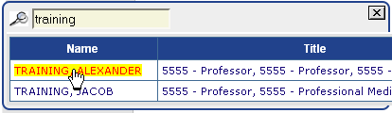
Enter a name into field available and click on the name found in the table below.

Individual Faculty Entry
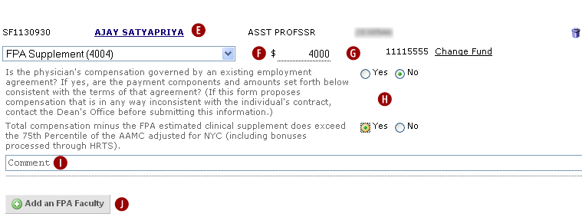
- You will see the faculty member's name, their title, and an associated reference number at the top of this section. (While working on the form in DRAFT, if you need to remove a faculty entry, click on the garbage can icon ).
- Select the appropriate supplement type from the drop down that is available.
- For each supplement chosen, you are able to add and delete funding sources and the allocation per fund.

Adding, Deleting and Changing Sources
Adding Sources: Clicking on the Add Fund link will expose the fund picker.
Type a fund name or number into the field available. The fund picker will begin to generate a list of funds that are available at the Medical Center as you are typing. Once you find the source, click on the fund code and it will be added as a source.
Splitting sources: To split the funding on a supplement click on the Add Fund link that appears directly under the present supplement source.
Deleting sources: Click on the garbage can icon to delete a line of salary source information.
Changing sources: To change a supplement source, you will need to delete the original source and then add a new one.
- All questions must be answered in this section of the form to be valid.
- In the comments section, you can enter a comment surrounding the transaction. This is the place you would want to specify faculty personally performed activities (e.g. CARTS, FPA Receipts, wRVUs).
- To add another faculty you can click on the Add an FPA Faculty button again. Repeat steps E through J as many times as needed.
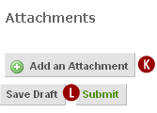
- Click the Add an Attachment button to do so.
- Click on Save Draft to save the work done on the form so that you can come back later and work further on it. Click on Submit to send the form forward for approvals. If you click on Submit and the form does not change its status up top, you may have missed a critical portion of information. Look for red text pointing out what is missing from the form and correct it appropriately.

Searching for a Faculty Supplemental Request
by daniel_klinger — last modified Feb 17, 2010 12:32 PM
Suggested Use: This is the only way to review terminated employees and vacant position actions in the system. As this is the broadest search available to departments, you will be able to find historical personnel action records for employees in the departments and subgroups that you have access to.
Navigation: HR > HR Transactions
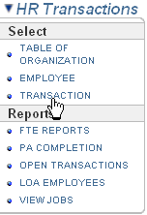
Select TRANSACTION from the left hand menu.
The Search tool will display.
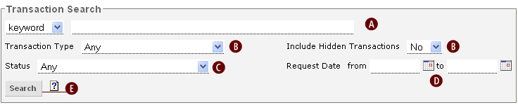

Using the Search to find a HR Transaction
- Enter a Keyword. See below for keyword search hints.
- Click on the drop-down menu to choose a transaction Type. Choose a Type to begin to narrow your transaction search. Select the show hidden check box as needed.
- Click on the drop-down menu to choose a transaction Status.
- Enter a date or set of dates. Using only one date in the from or to field will constrain your search from a certain time. Using two dates will constrain your search to a certain time period.
- Click the Search button. Search results will be shown in a summarized table below the search.
- Click on the transaction number for further review. You may need to narrow your constraints further. Read the Search Hints.

Search Hints:
• Use the most specific terms you can. For example, use request number, PO number,
name, etc.
• Use as few search terms as possible. If adding a term to the criteria is not likely to
narrow down the results, don't add it.
• Avoid words that may appear very frequently (even popular vendor names). The most
common and generic terms, such as the, a, of, inc etc., are ignored by the system
unless they are part of a phrase.
• If you are looking for a phrase, quote the terms. For example: "black pen"
• Rely on exact matching where possible. For example, searching for pen will find
one pen, but not many pens.
• If you need to use a wildcard, then affix a star after the word: pen* will match
pen, pens, pencil, etc.

Supplemental Types and Descriptions
by Daniel Klinger — last modified Nov 17, 2009 02:43 PM
Supplemental Type (and associated object code) | Description - Compensation entitled to physicians based on......
FPA Supplement (4004) | FPA clinical activities performed
Administrative Supplement (4026) | Administrative roles besides their clinical activity
Non-FPA Supplement (4027) | Activities that are non-FPA related. E.g. "Faculty  working in another department".
Research Supplement (4028) | Research roles

Document Actions
- Send this
- Prin

